

KING ABDUL AZIZ UNIVERSITY

COLLEGE OF COMPUTING AND INFORMATION TECHNOLOGY

DEPARTMENT OF INFORMATION SYSTEM

PROJECT MANAGEMENT CPIS-334 LAB Fall term 2022

Project Worksheet

Detailed Project Schedule (MS Project)

Course Instructor: Fatima Habib

Lab Instructor: Waad Alshehri



MSHL Vehicle Rental System

**An Online Vehicles Rental System**

|  |  |  |
| --- | --- | --- |
| Name | ID | Section |
| Shaima Abdullah Bashammakh | 1914892 | A1A |
| Majd Saleh Alzahrani | 1816903 | A1A |
| Loujain Mohammed Alghamdi | 1808114 | A1A |

Table of Contents

1.Purpose of the Project 3

2.Goals and Objectives 3

2.1. Goals 3

2.2 Objectives 3

2.3 Project Charter 4

2.4 Scope Statement 5

3.Work Breakdown Structure (WBS) 6

4. Project Schedule Network Diagram (Project Scheduling) 7

5. Staffing Procedure and Plan (HR Management) 9

6. Organizational chart and histogram (HR Management) 9

7. Major Project Milestones (Demonstrate using MS Project) 11

8. Detailed Project Schedule (MS Project) 12

8.1 Screenshot of Each Step (MP Project) 13

# 1.Purpose of the Project

In our project management project, we will create a project management plan for an online vehicle rental system. MSHL vehicle rental system is a web-based application which purpose is to allow users to lease small vehicles such as bicycles, scooters, and motorcycles in an easy and fast way that saves the customer's time.

These vehicles play a role in entertainment, sports, and health improvement. Another purpose is to allow users a flexible transportation, a drop in vehicle emissions, less traffic on the roads, reasonably priced frequent commutes, and ease of accessibility.

# 2.Goals and Objectives

## 2.1. Goals

• Enables faster booking for customers.

• Offers a simpler approach to look for transportation options.

• Benefits users greatly, it is more convenient than paying for the ownership and maintenance.

• Lends vehicles for a price for a few hours, a few days, or a week or more.

• Enables Customers to choose the desired brand, size, and color.

• Enables Customers to reserve their vehicles from anywhere in the county.

• Saves customers’ time by avoiding the need to call and wait for a car.

## 2.2 Objectives

• Allow users a quick access to all the system's services and schedule appointments according to their preferences.

• Automate management to enable staff members to control the rental system more effectively.

• Enable the system's maintenance and the addition of new services. Also allow including any prepaid and discount vouchers for the clients.

• It must offer clients protection, privacy, and assistance.

• It must provide a simple and user-friendly interface for clients.

• Take into consideration any issues that may arise during development to ensure that the system is error-free.

• Create a database that stores all clients' information to eliminate data redundancy.

## 2.3 Project Charter

|  |
| --- |
| Project Title:  MSHL Vehicle Rental System |
| Project Start Date:  25/10/2022  Project finish Data:  23/02/2023 |
| Budget Information:  The Project’s budget is 272,860.00 SAR. |
| Project Manager:  Name: Mashael Alshehri  Phone Number: +(966)556322732  Email: Mashael_Alshehri@gmail.com |
| Project Objectives:   1. Create and design a system for Leasing vehicles where clients may view a list of options that include varied brands, colors and sizes of bicycles, scooters, and motorcycles. 2. Make an appointment and leave a review of services and staff. 3. The system allows the administrator to control the clients' appointments and update the list of services, including price. |
| Main Project Success Criteria:   To ensure the success of our project, the project manager must meet the following constraints:  1- scope:   * for the client: View all accessible service information. * for administrators and employees: Manage service details, view client information and vehicles bookings.   2-Time: The expected date to complete the project is 23/2/2023.  3-Cost: The project cost does not exceed 272,860.00 SAR.  4-Quality: Gain client's satisfaction, trust, and a positive reputation for the services provided by the system. |
| Approach:   * Develop a flexible, simple, and user-friendly interface. * Test and check the software performance, quality, and flexibility. * Update the information technology inventory database to determine and upgrade needs. |

## 2.4 Scope Statement

This project will deliver an online vehicles rental system which is an application that allows clients to book an appointment to lease a bicycle, a scooter, or a motorcycle through an online platform.

MSHL vehicle rental system will enhance the customer's experience by allowing the user to browse a list of vehicles, select one, schedule a leasing appointment, number of leasing days and payment options.

The project will also deliver a new database to hold customers’ information, along with a database server to house the data.

The project requires the project team to create a software system and a user-friendly interface where clients can write and read reviews about the services system, the project also requires the project team to make sure that all stakeholder requirements are met.

# 3.Work Breakdown Structure (WBS)

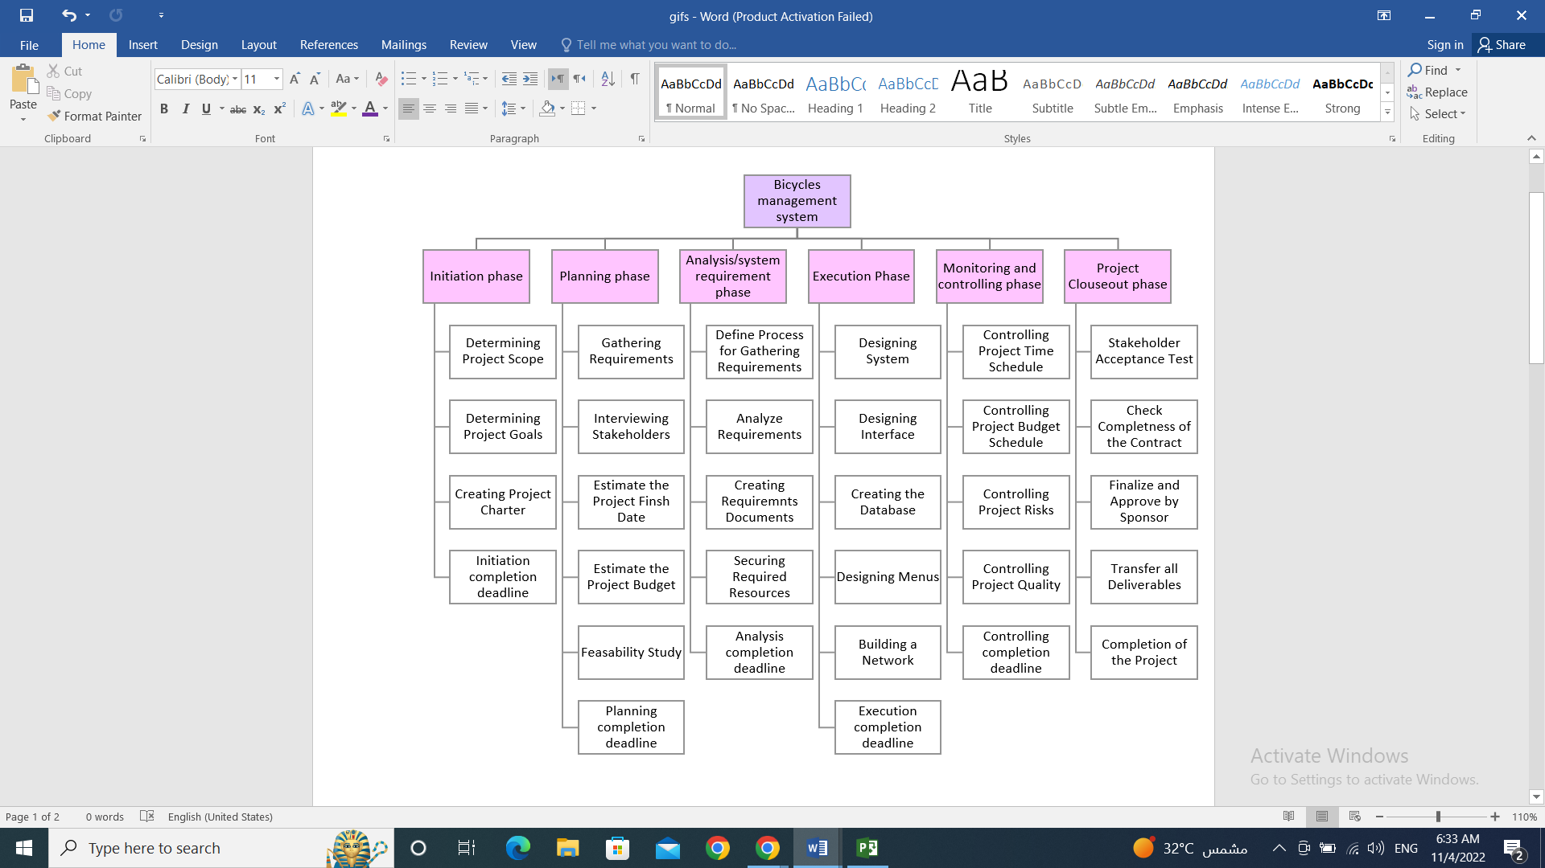

MSHL vehicle rental system

# 4. Project Schedule Network Diagram (Project Scheduling)

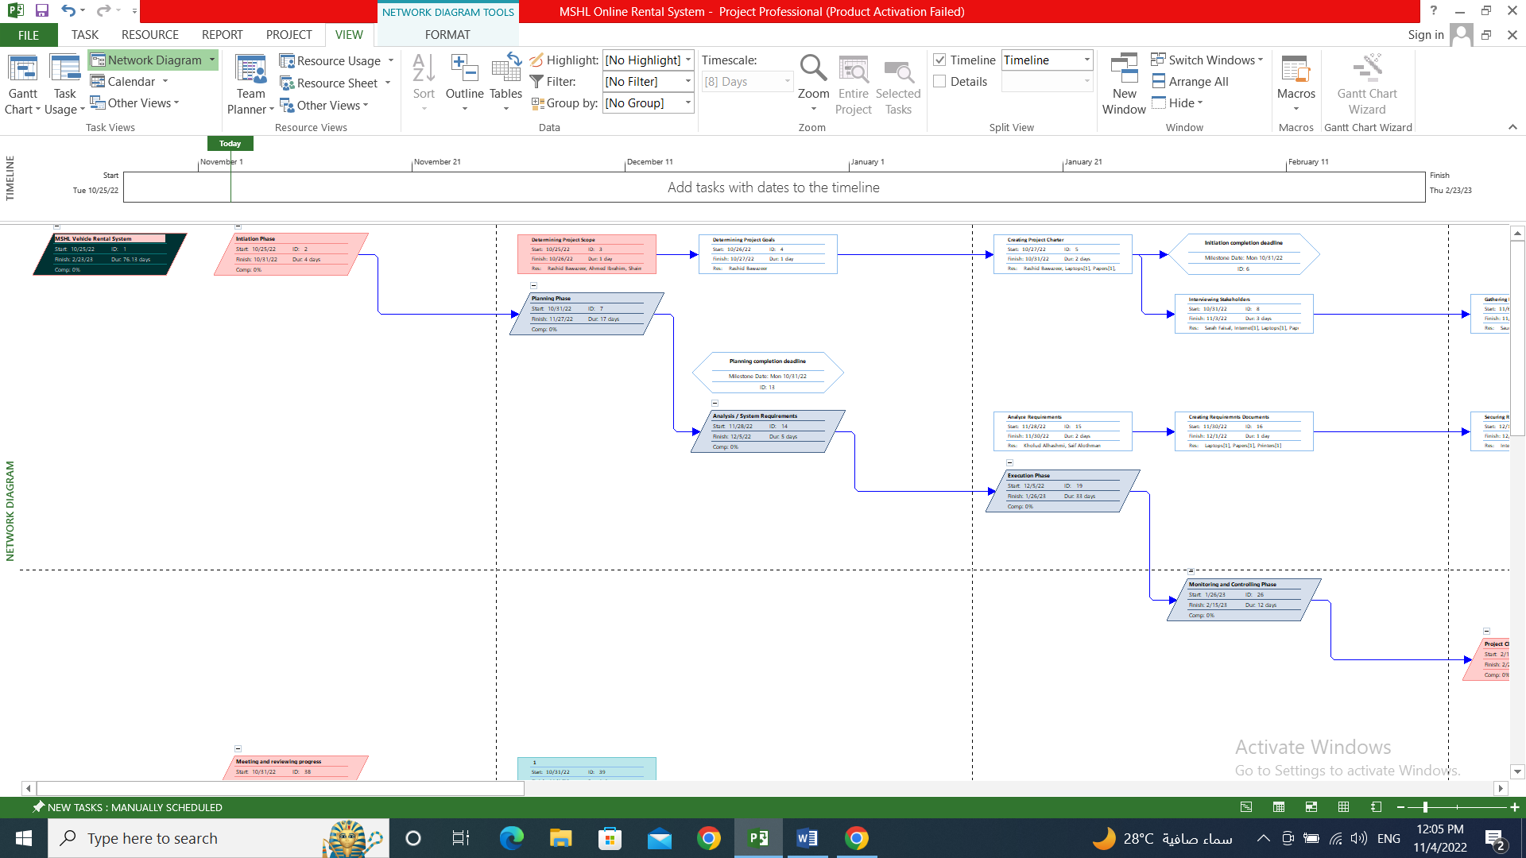

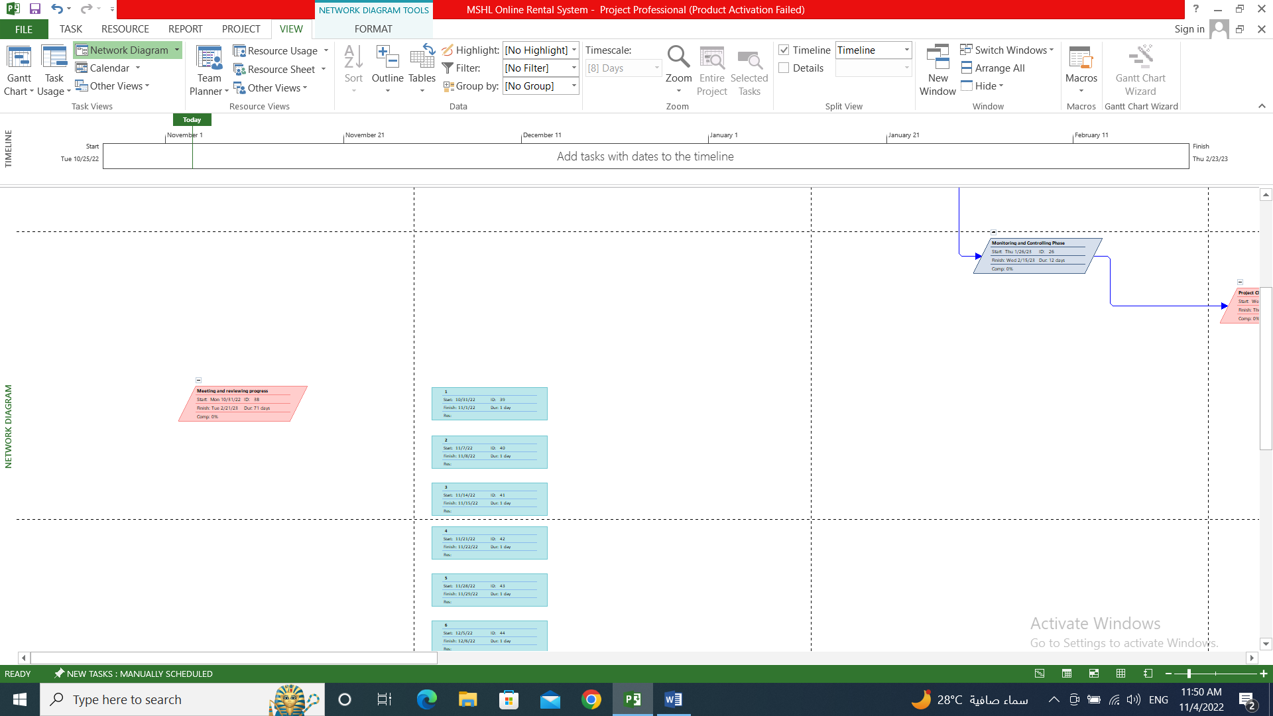

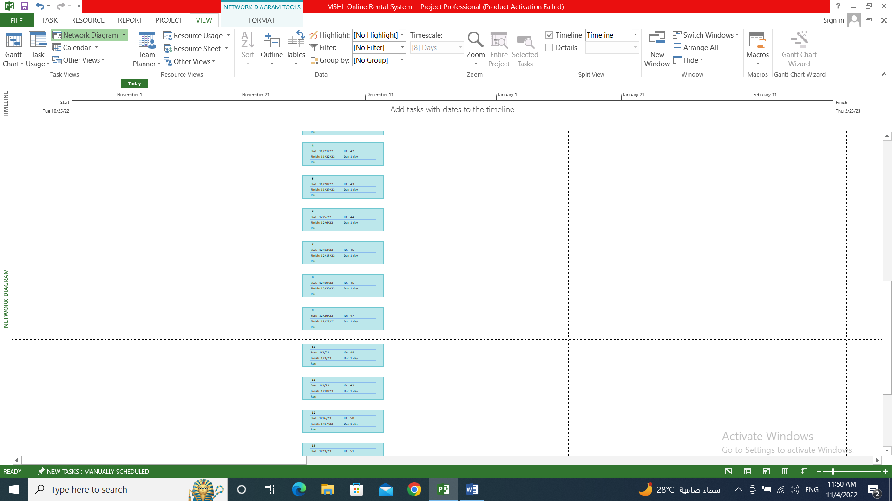

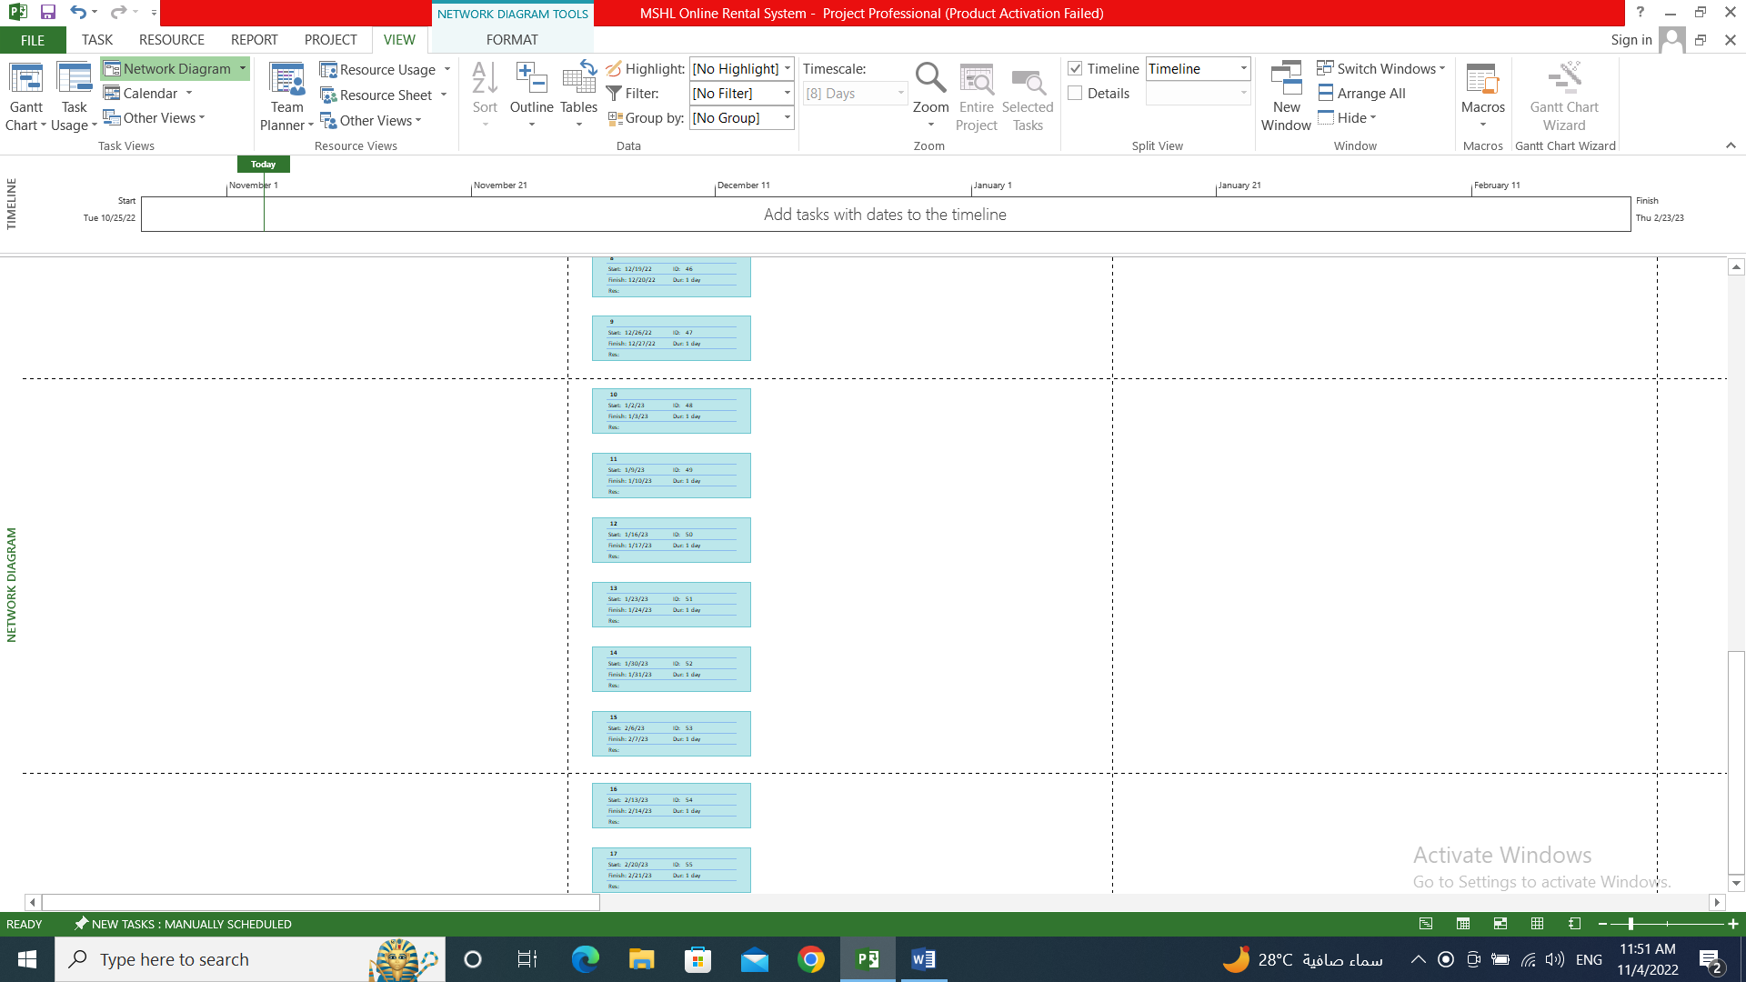

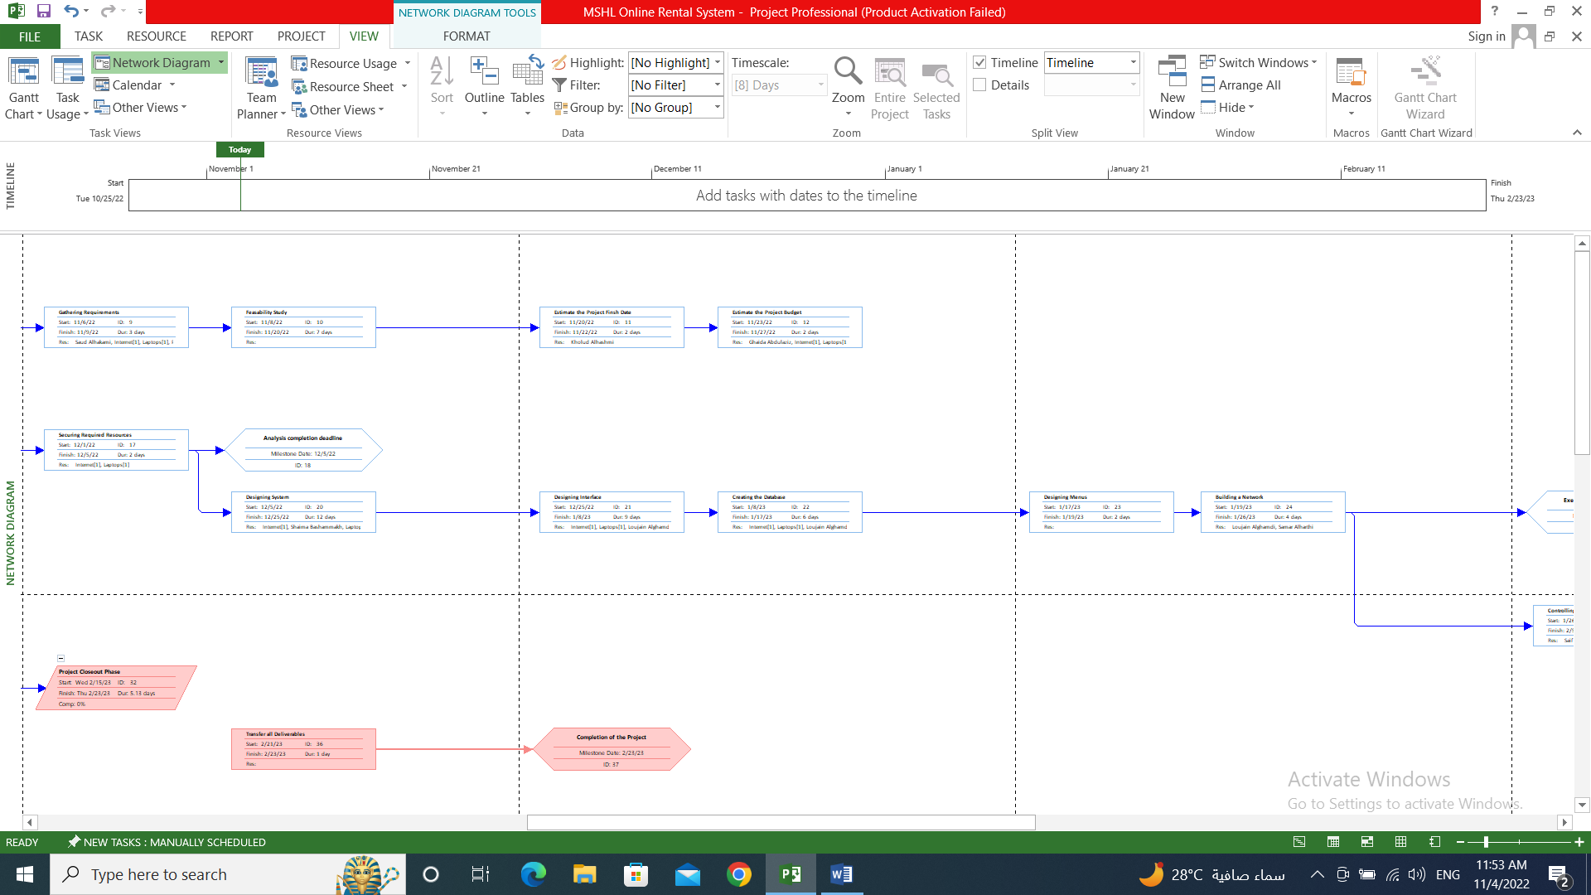

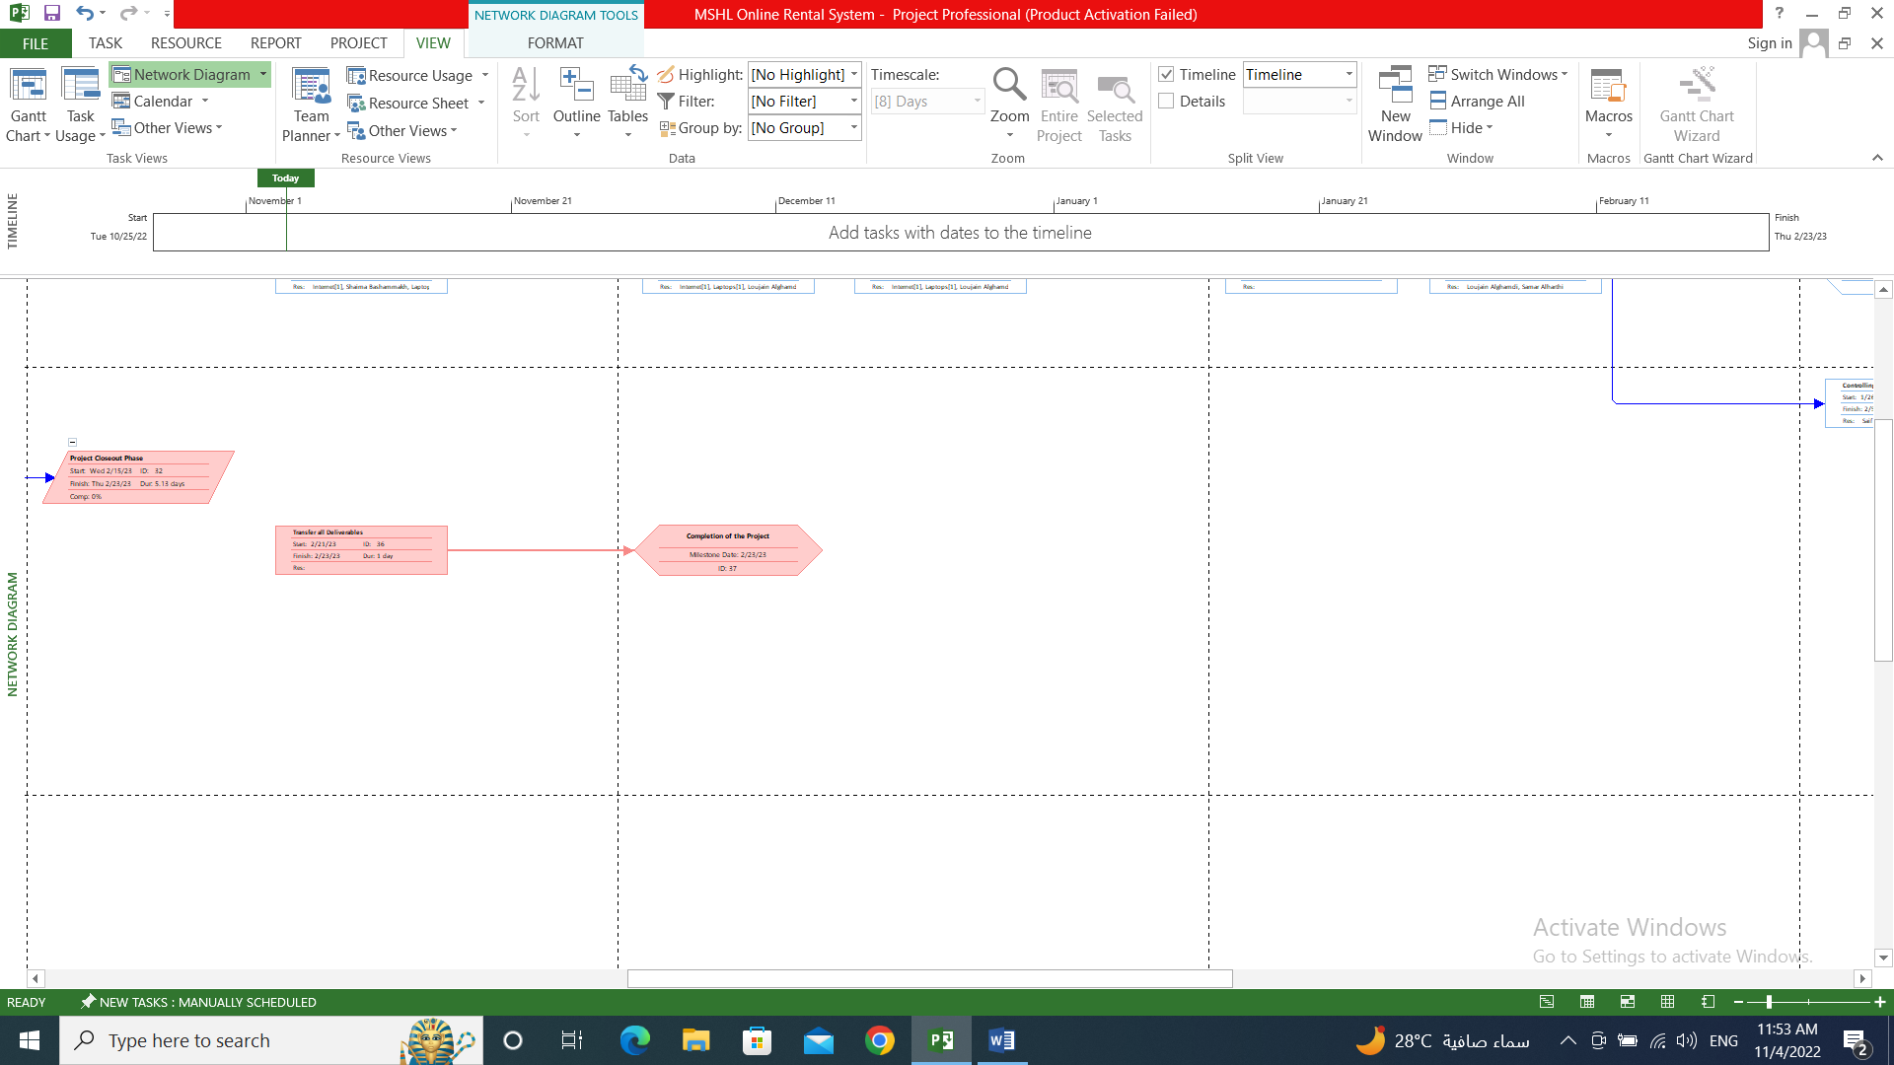

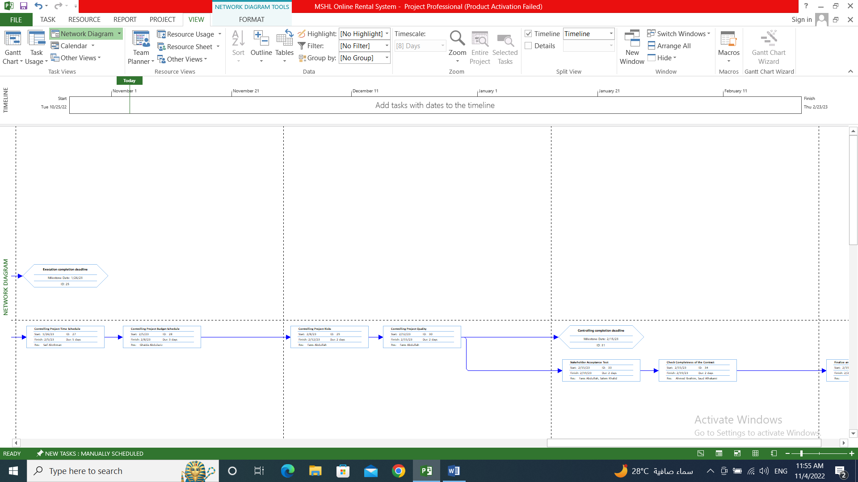

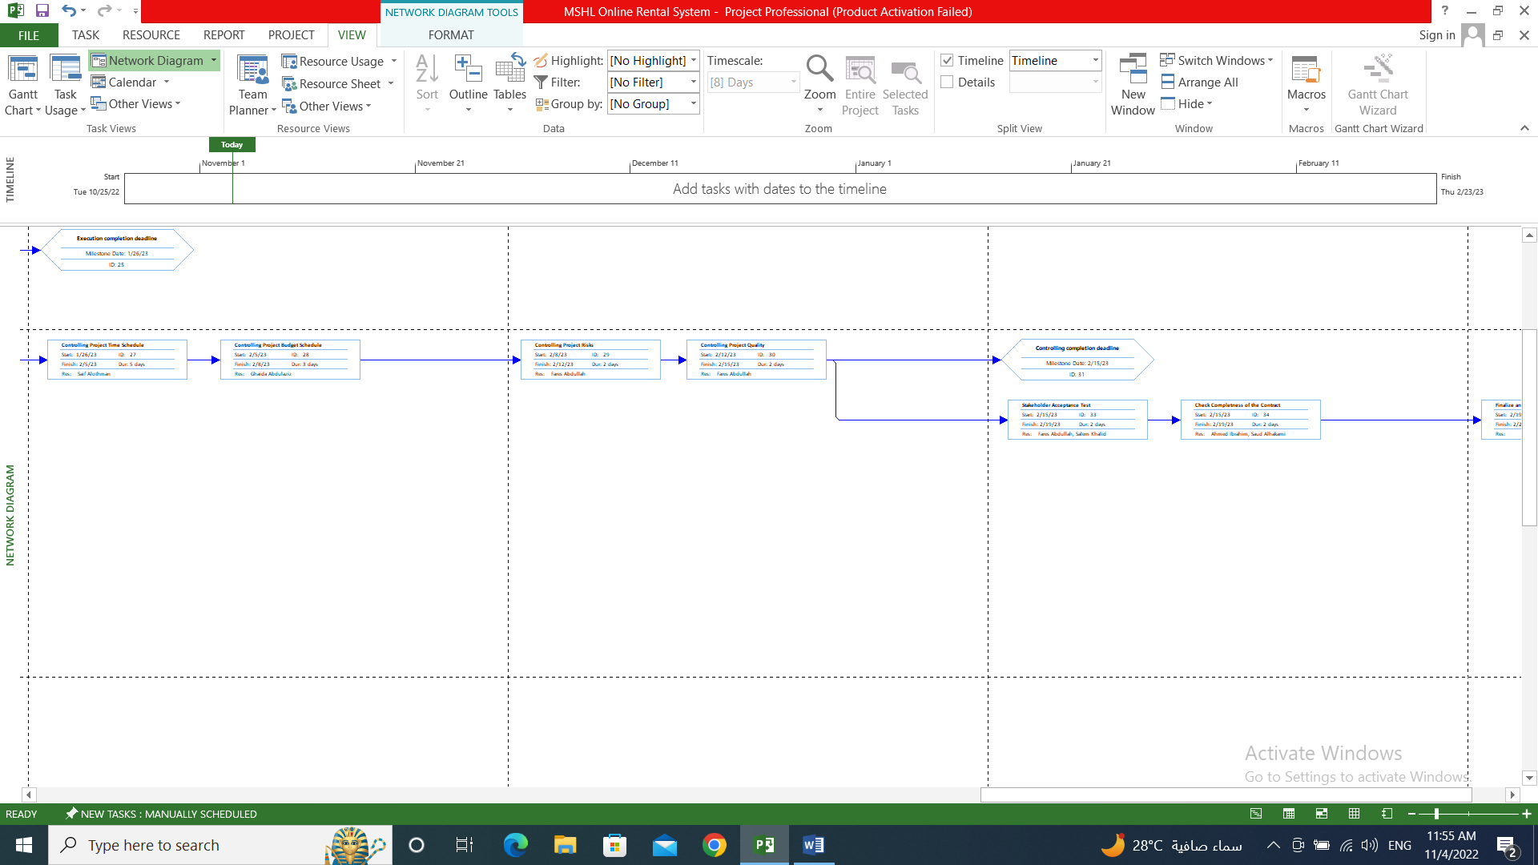

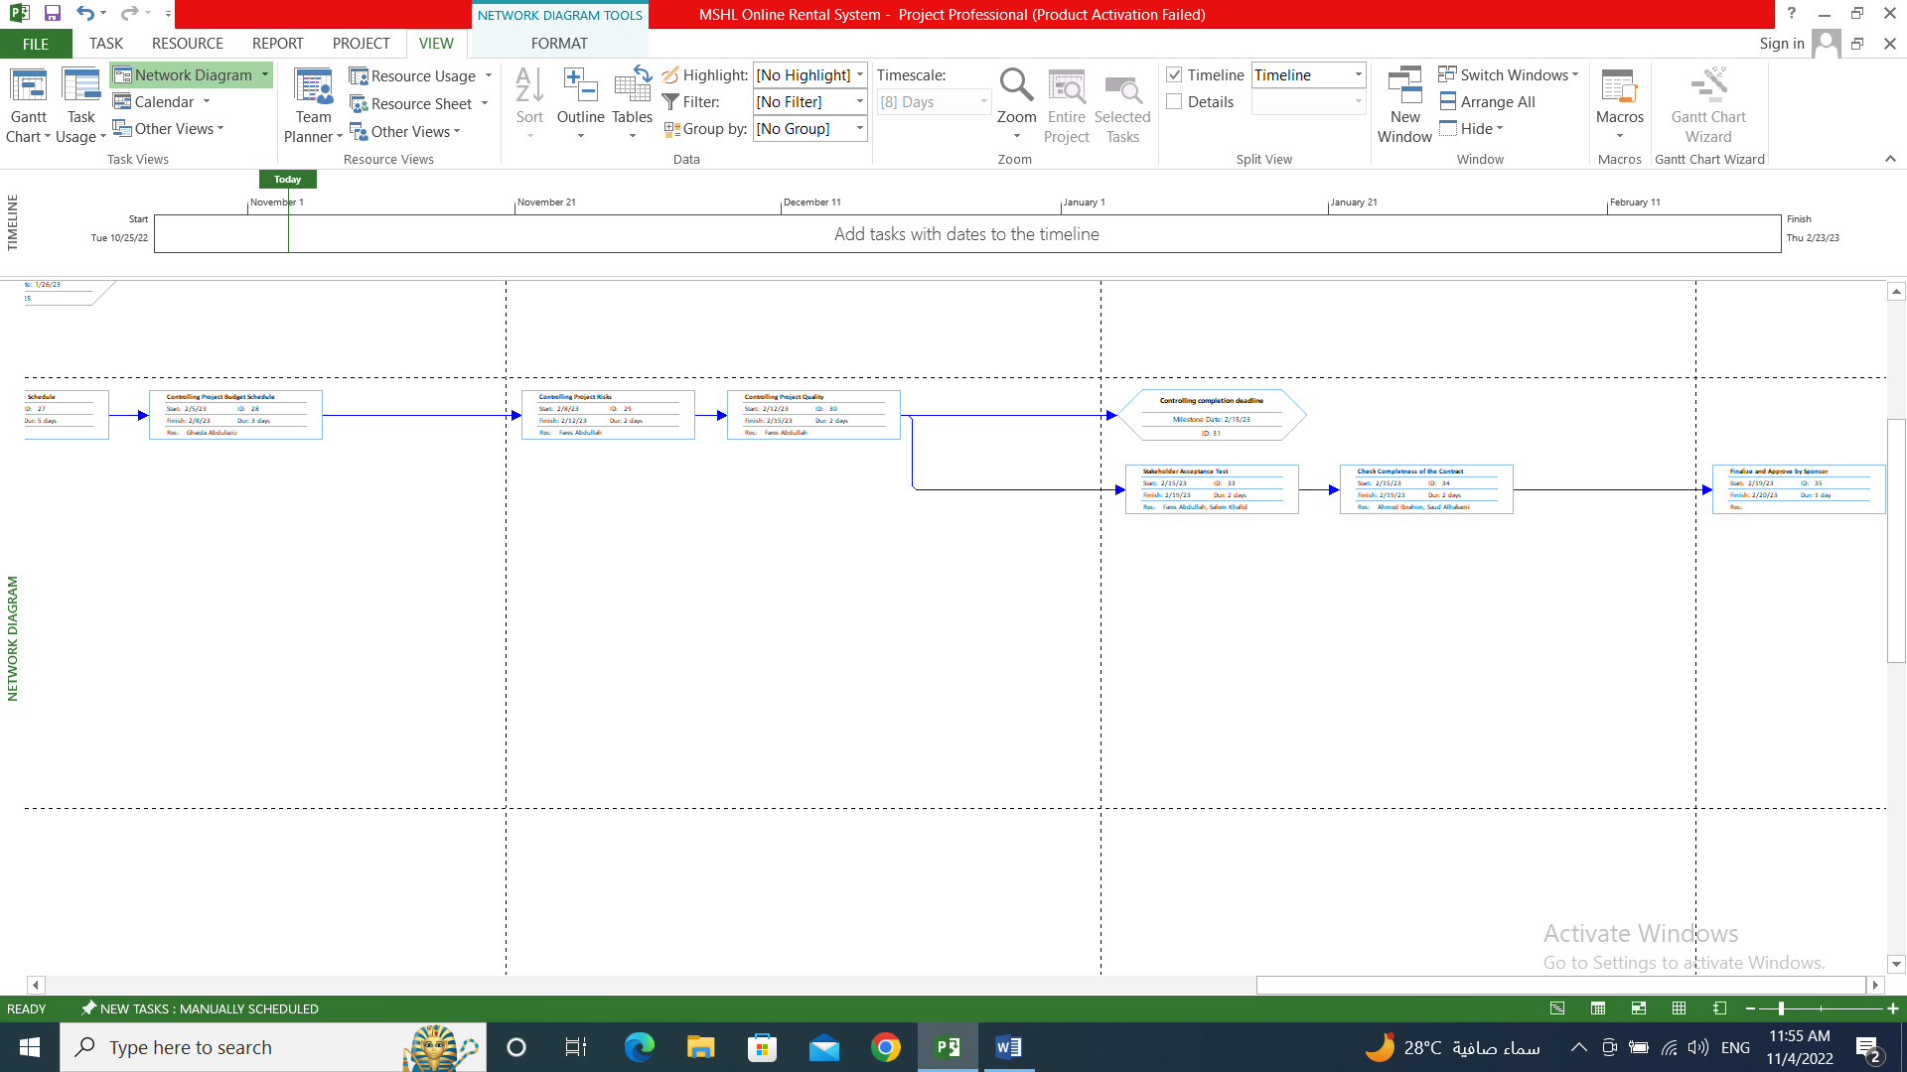

# 5. Staffing Procedure and Plan (HR Management)

• Determining acceptance criteria for each job.

• Designing an appropriate advertisement that includes the vacancies with the required skills and contact information.

• Publishing advertisement on social media and perfect advertising sites.

• Receiving the applicants for the jobs.

• Sorting the applicants and choosing the optimum and the best for the job/s based on the job's acceptance criteria.

• Making interviews for the candidates.

• Taking the approvals of the candidates to work and sign the contract of work with them.

• Introducing employees to the working environment.

• Providing a training for employees.

# 6. Organizational chart and histogram (HR Management)

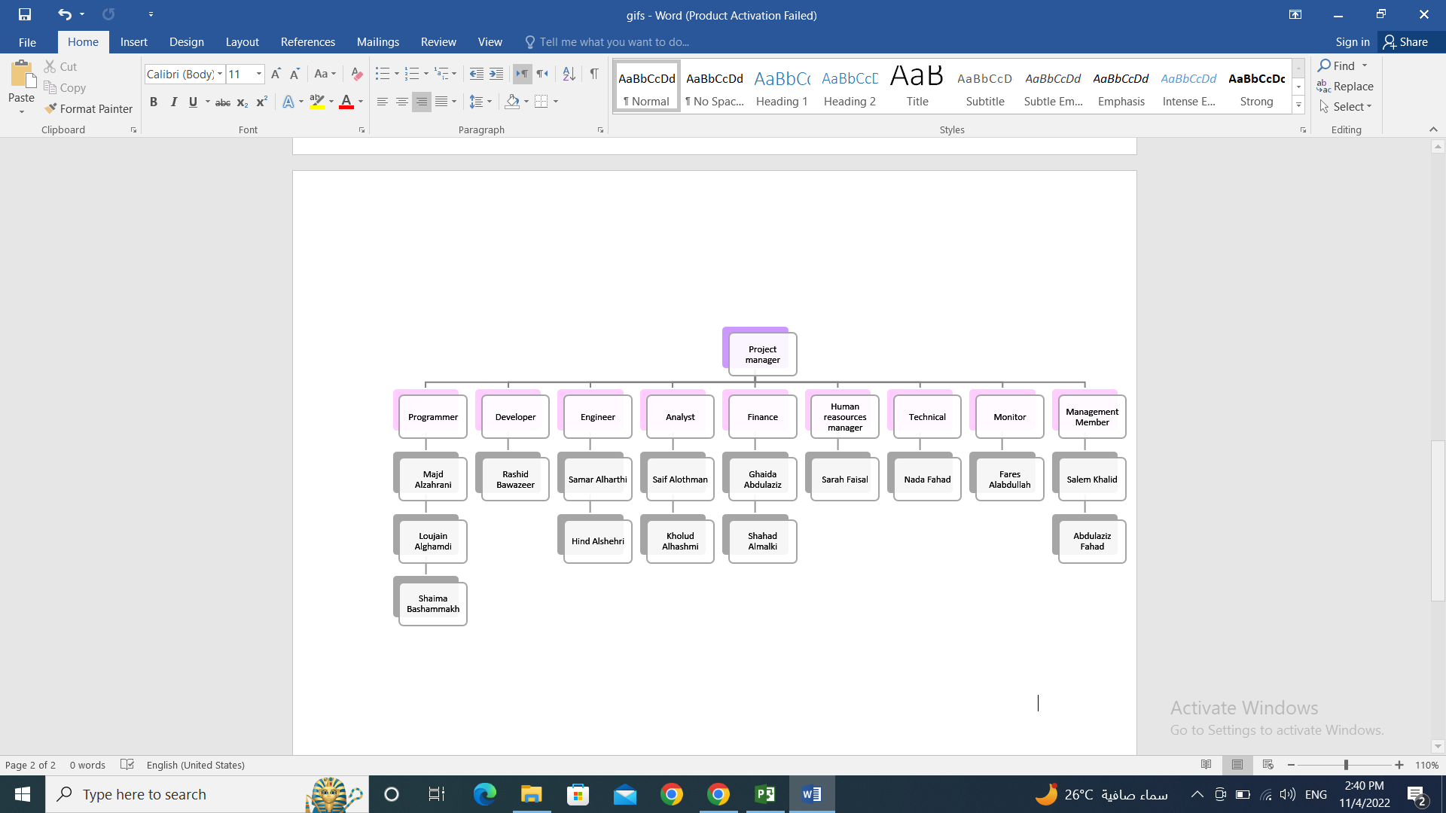

# 7. Major Project Milestones (Demonstrate using MS Project)

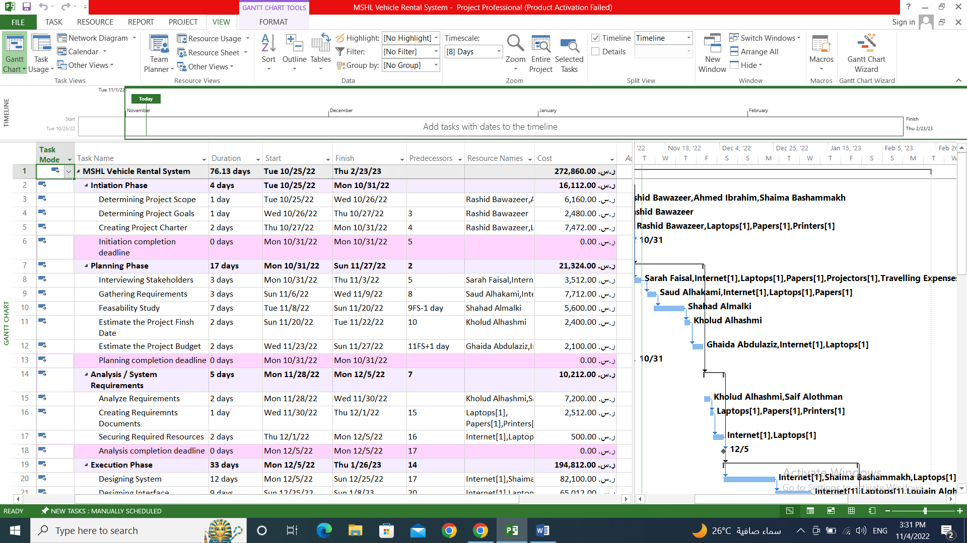

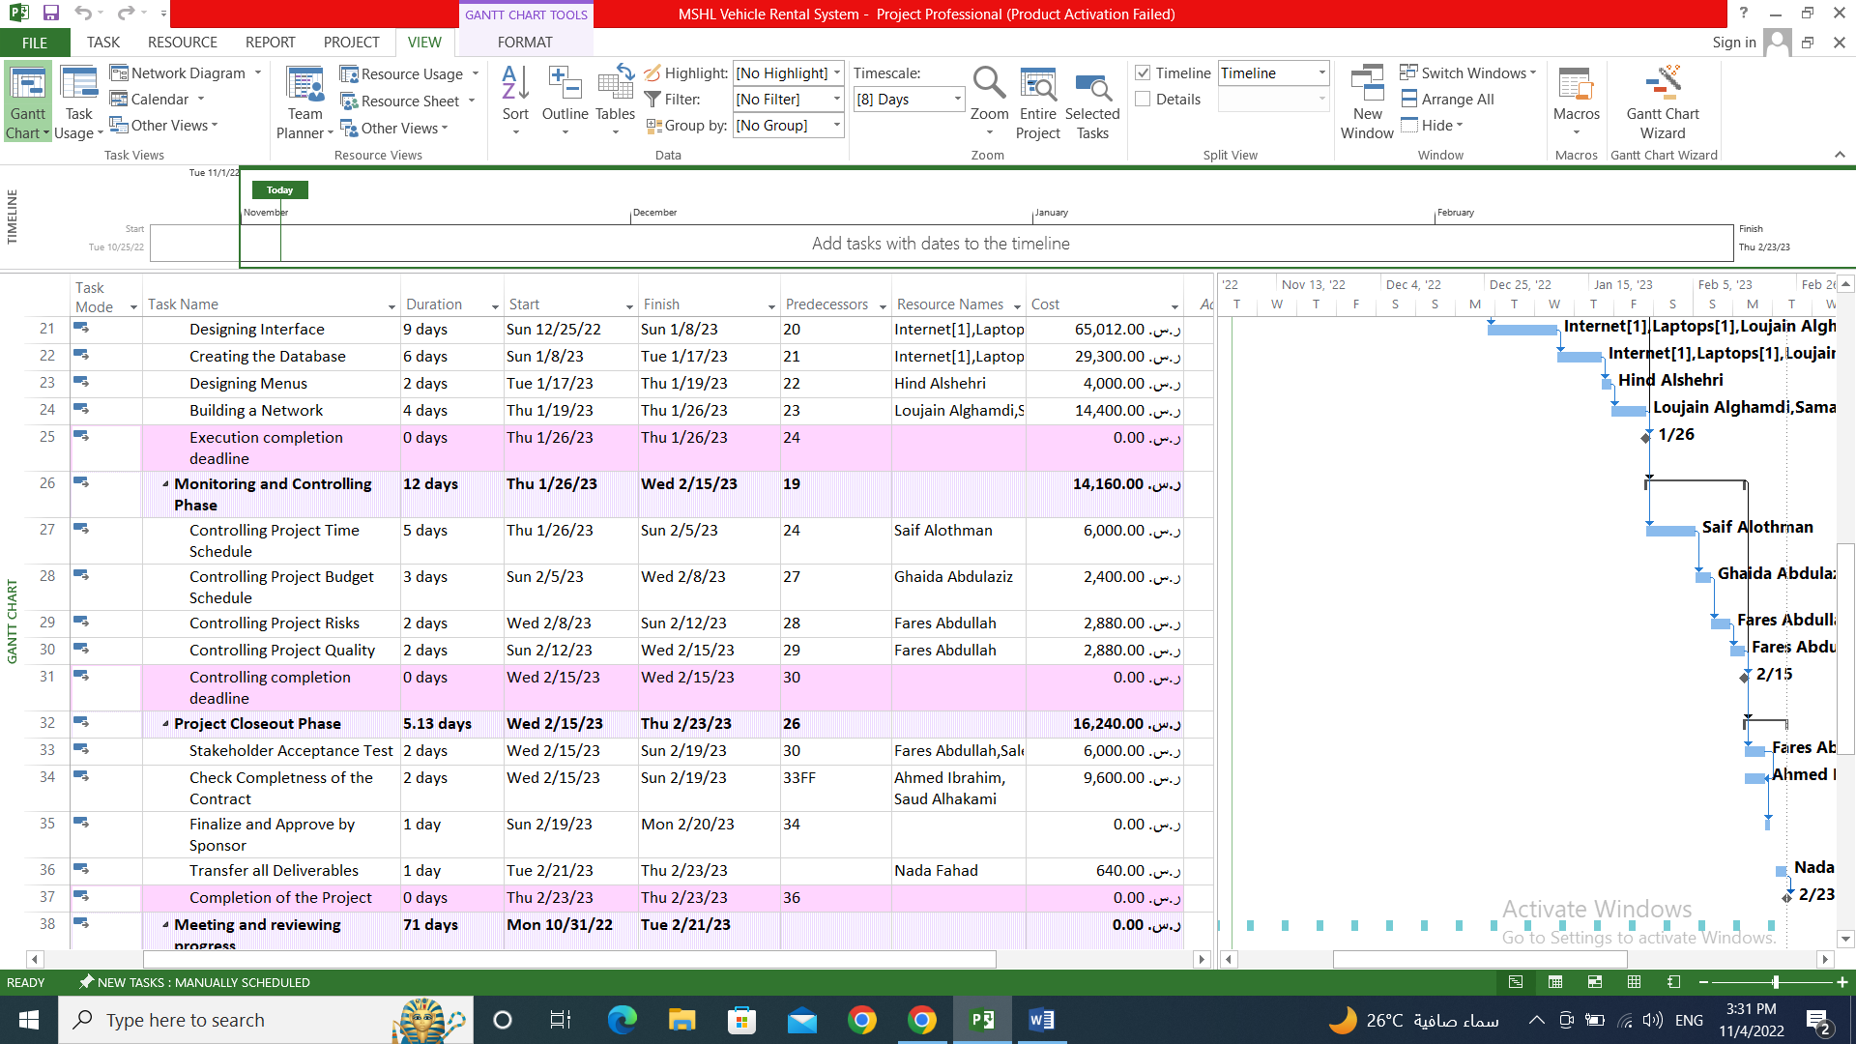

# 8. Detailed Project Schedule (MS Project)

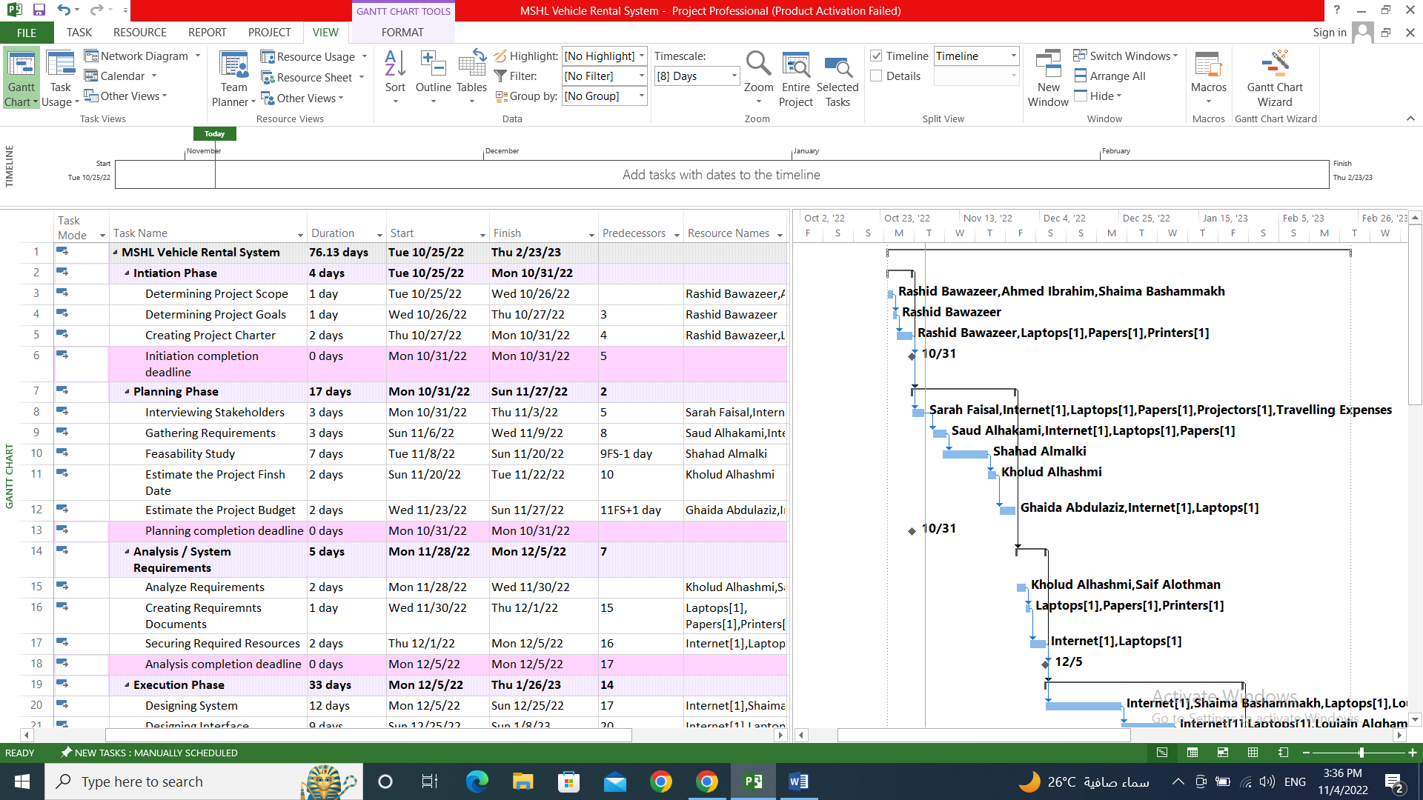

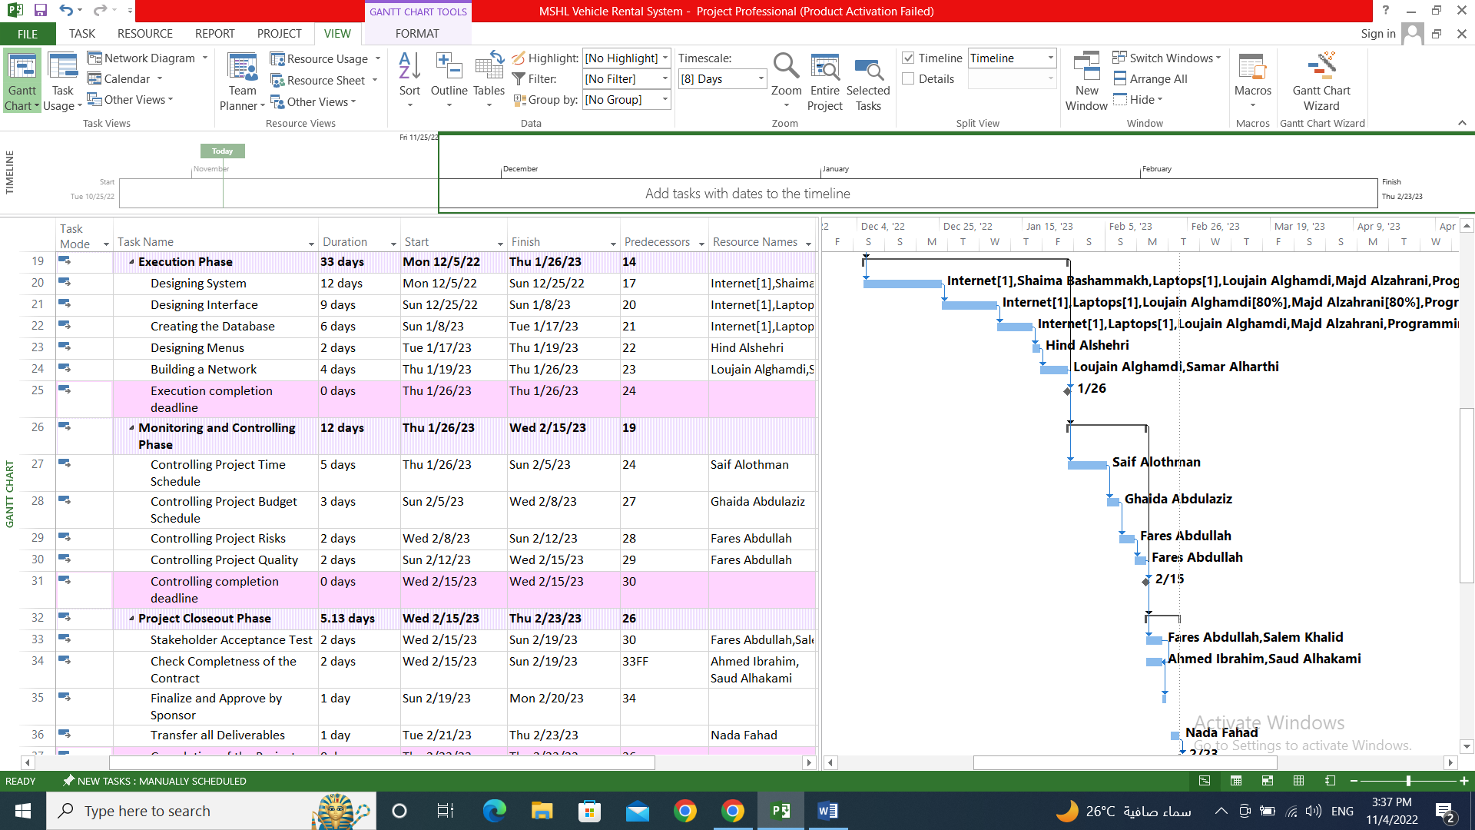

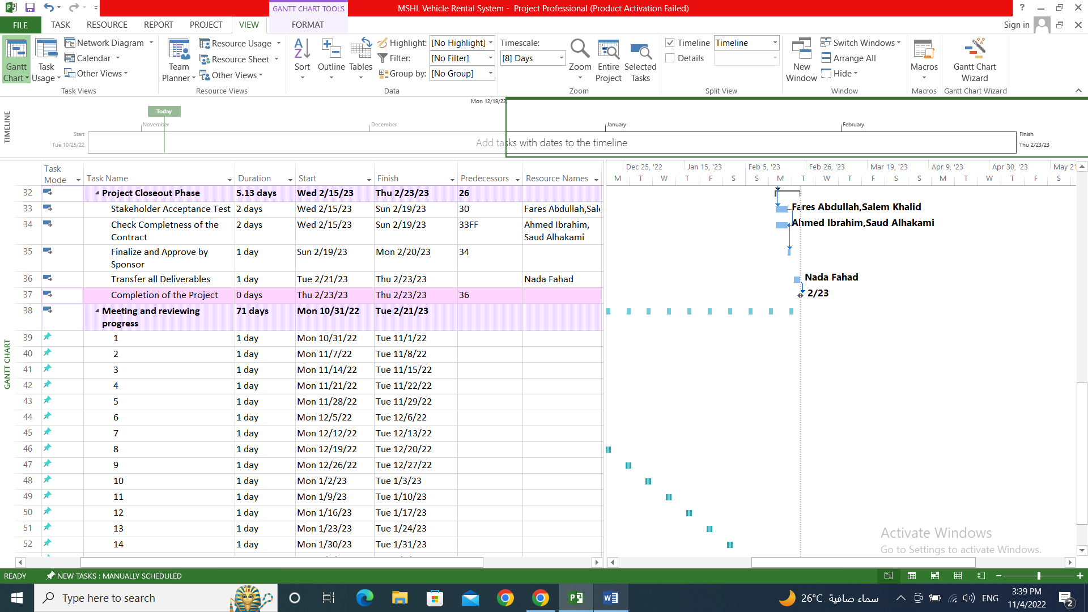

## 8.1 Screenshot of Each Step (MP Project)

